Test Execution Report
Project Information
Project Name: ParaBank Automation Testing Framework
Automation Tool: Selenium WebDriver
Framework: Cucumber BDD
Build Tool: Maven
CI/CD Tool: Jenkins
Containerization: Docker
Reporting: Cucumber Reports, Extent Reports
Source Control: GitHub(https://github.com/2002Umesh/Capstone_Project.git)

Test Execution Summary
Metric | Count
Total Features Executed | 8
Total Scenarios Executed | 8
Passed Scenarios | 8
Failed Scenarios | 0
Skipped Scenarios | 0
Pass Percentage | 100%
Fail Percentage | 0%

Module-wise Execution Status
Module | Scenario Status
Registration Module | Passed
Login Module | Passed
Open New Account Module | Passed
Bill Payment Module | Passed
Find Transactions Module | Passed
Transfer Funds Module | Passed
Request Loan Module | Passed
Update Contact Information Module | Passed

Cucumber Execution Summary
Metric | Count
Total Scenarios | 8
Passed | 8
Failed | 0
Pending | 0
Execution completed successfully with all scenarios passing.

Maven Build Summary
Activity | Status
Maven Clean | SUCCESS
Dependency Resolution | SUCCESS
Test Execution | SUCCESS
Report Generation | SUCCESS
Result: BUILD SUCCESS

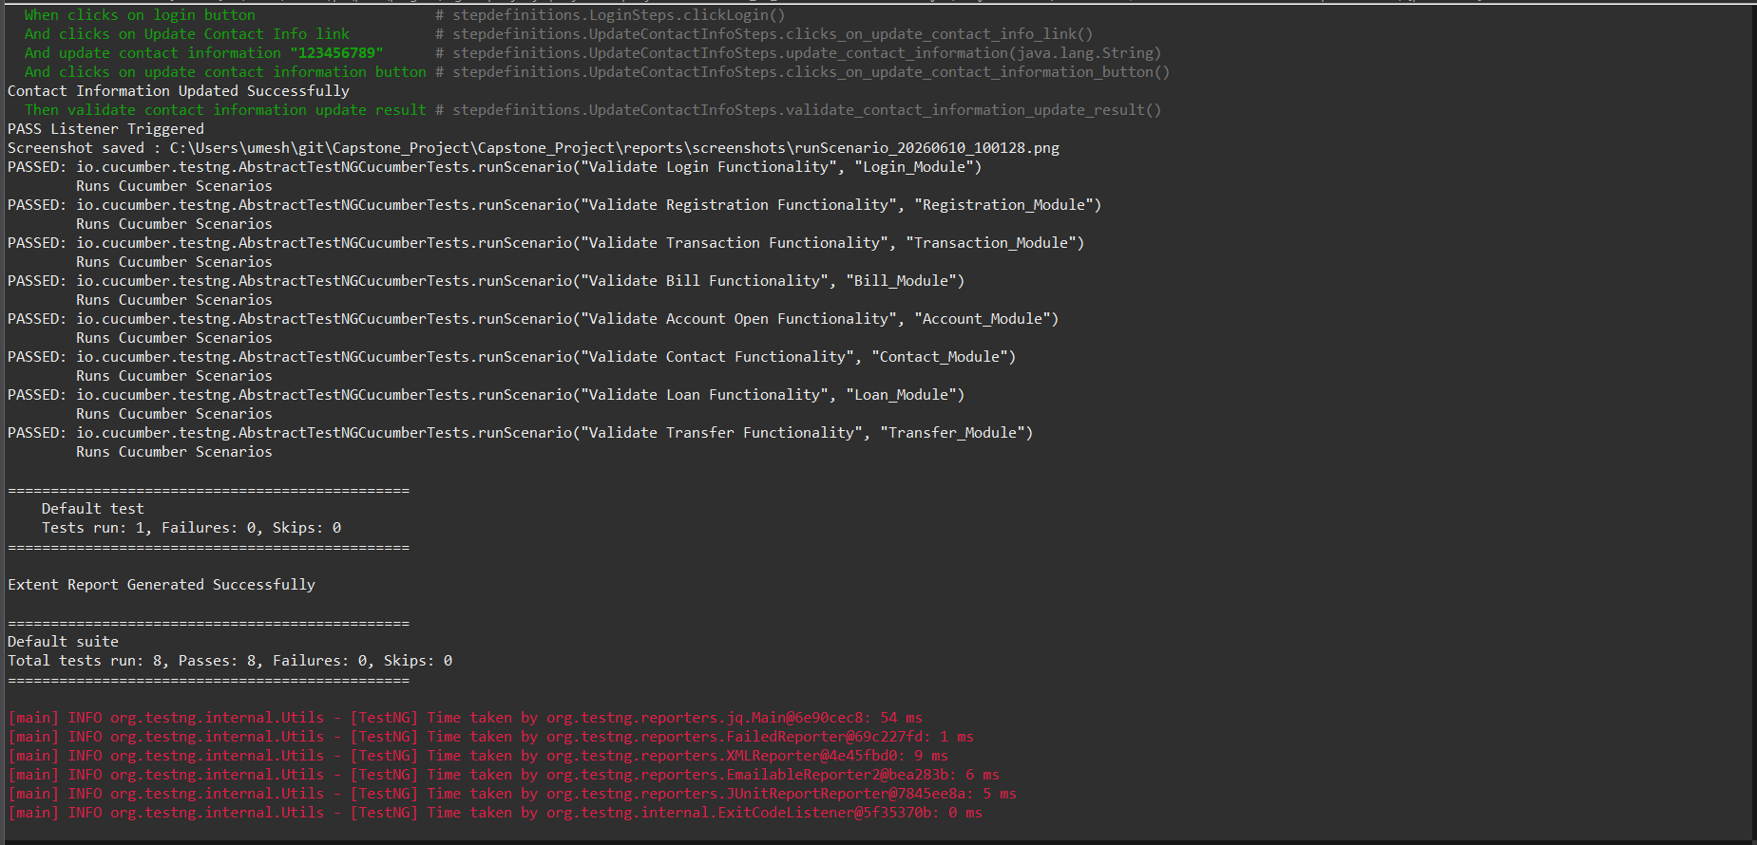
Jenkins Pipeline Summary
Stage | Status
Source Code Checkout | SUCCESS
Build Execution | SUCCESS
Test Execution | SUCCESS
Report Generation | SUCCESS
Pipeline Completion | SUCCESS
Overall Build Status: SUCCESS

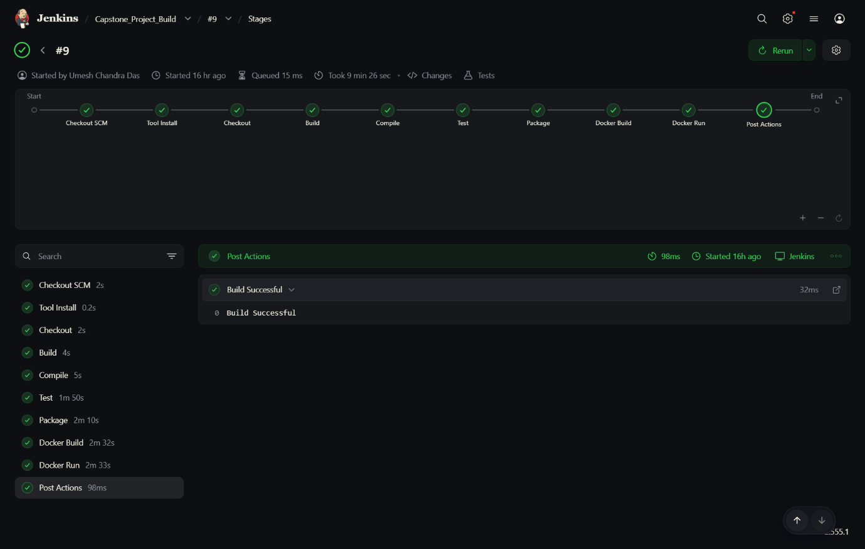

Docker Execution Summary
Activity | Status
Docker Image Build | SUCCESS
Docker Container Creation | SUCCESS
Framework Execution | SUCCESS
Container Exit Status | SUCCESS

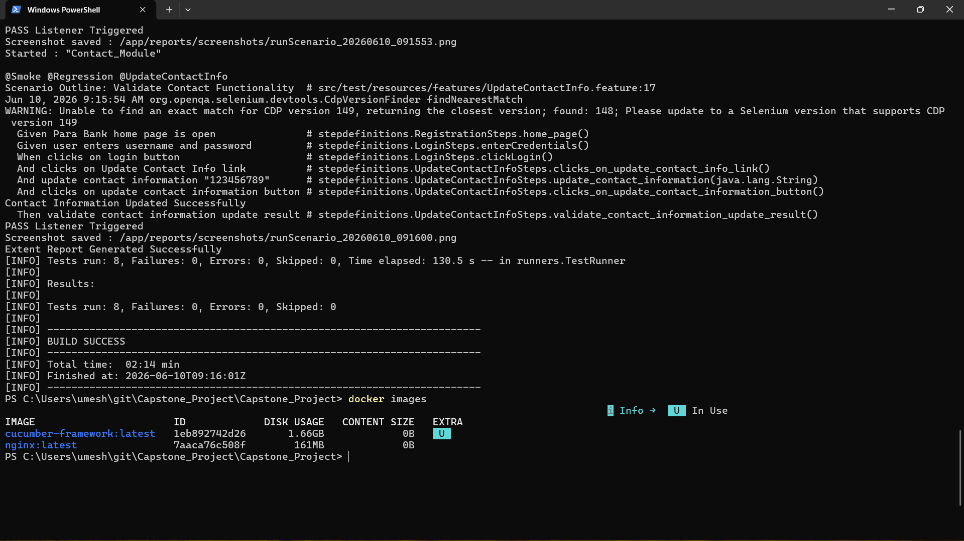
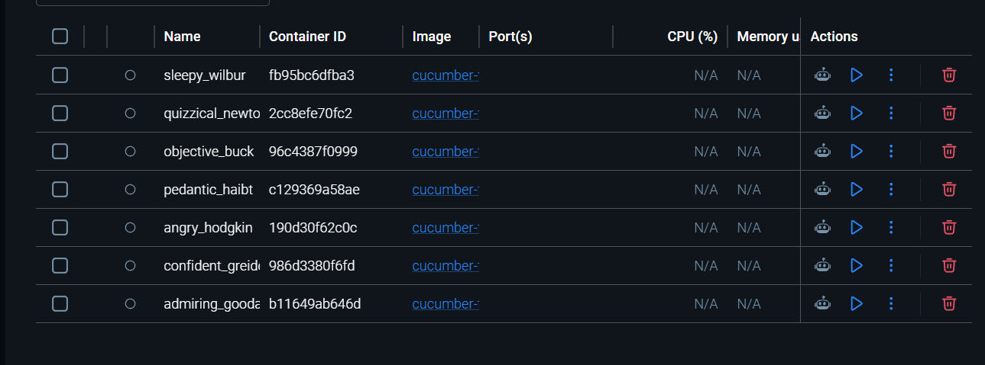
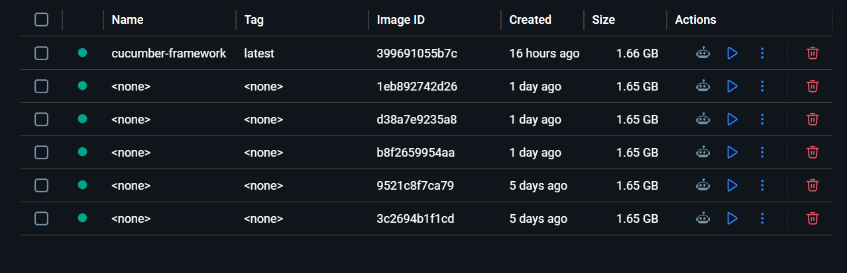

Extent Report Summary
- Extent Report generated successfully.
- Scenario-level execution details available.
- Execution screenshots captured automatically.
- Pass/Fail statistics displayed in dashboard.
- Detailed execution logs available for each scenario.
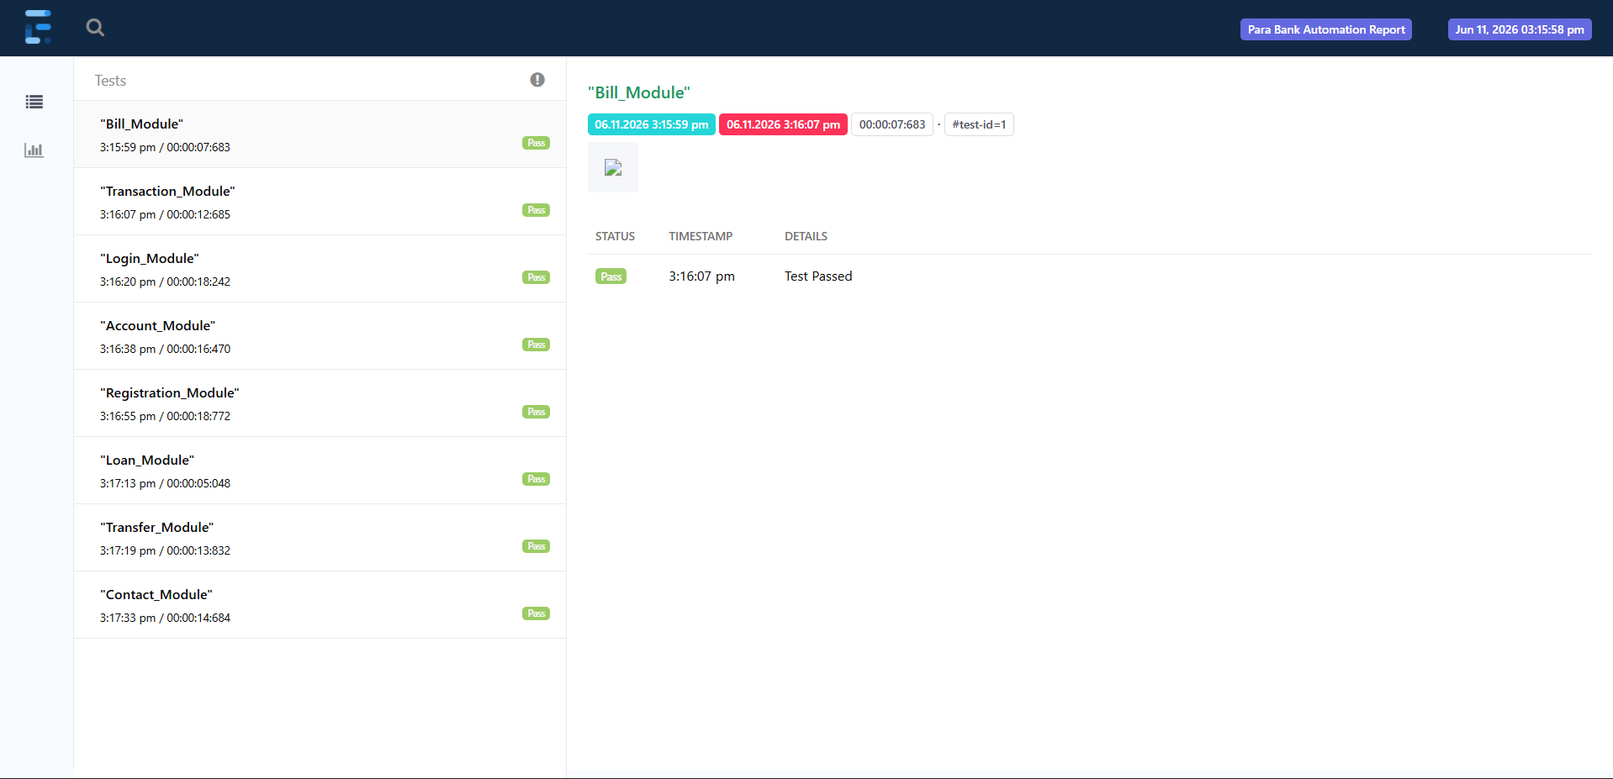
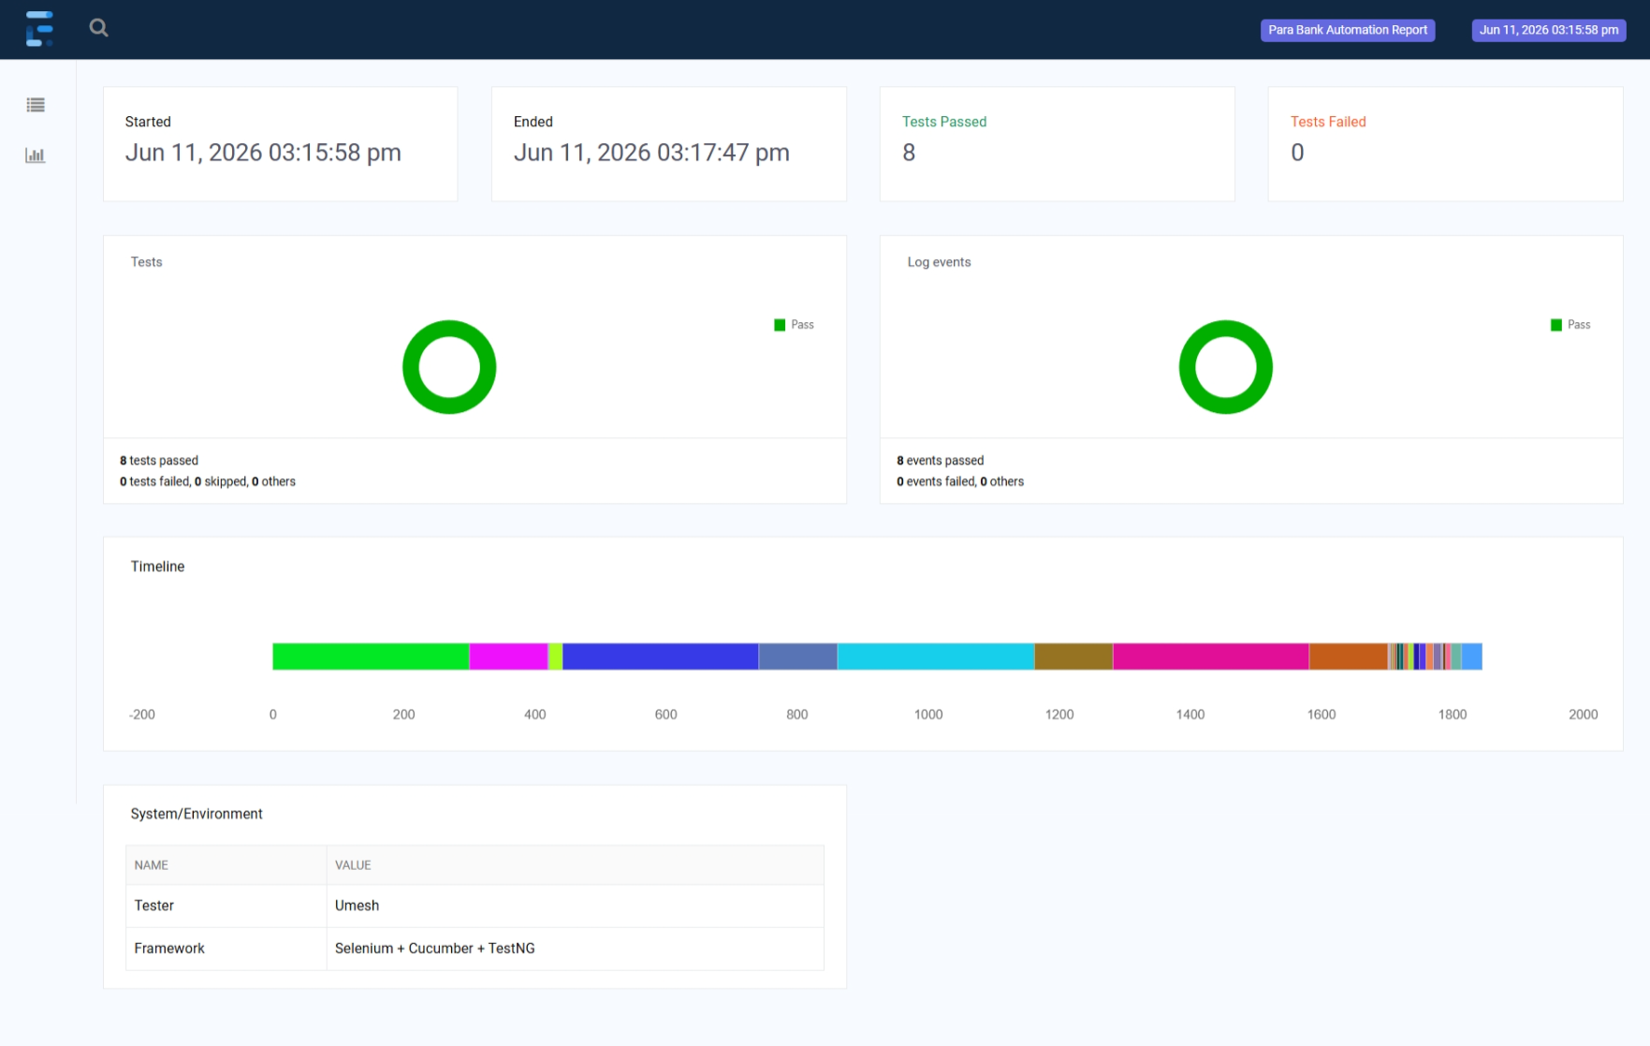

Conclusion
The ParaBank Automation Testing Framework was successfully executed using Selenium WebDriver, Cucumber BDD, TestNG, Maven, Jenkins, and Docker. A total of 8 automated scenarios across key banking modules were executed with a 100% success rate. Jenkins CI/CD integration and Docker-based execution were validated successfully. Extent Reports and Cucumber Reports confirmed successful execution of all implemented test scenarios and verified framework stability.

